**E! nexus**

**(Entertainment)**

**Design Document**

**Submitted To: Submitted by:**

Mr. Paramjeet Rana Aditya Mahajan CO10303

Anchit Jatana CO10307

Nishaant Kapoor CO10330

Varun Nagrath CO10355

**Home Page Structure**

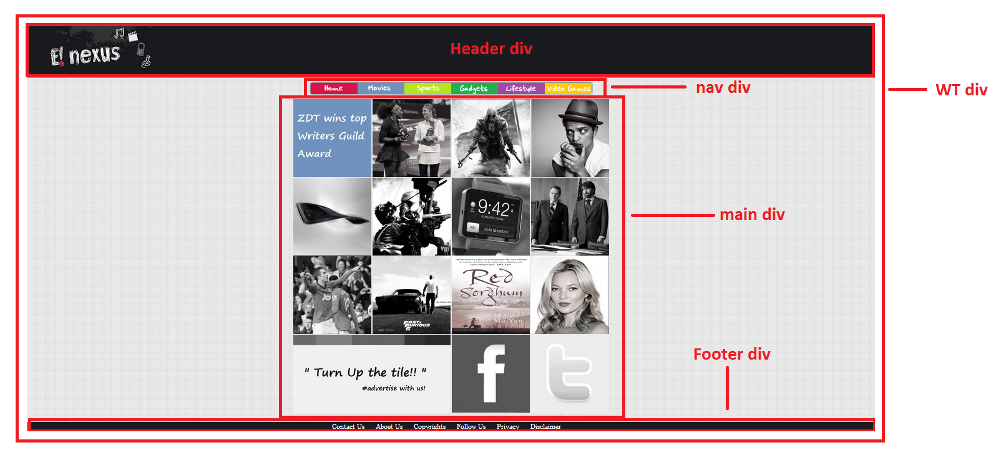

**Internal Main Page Structure**

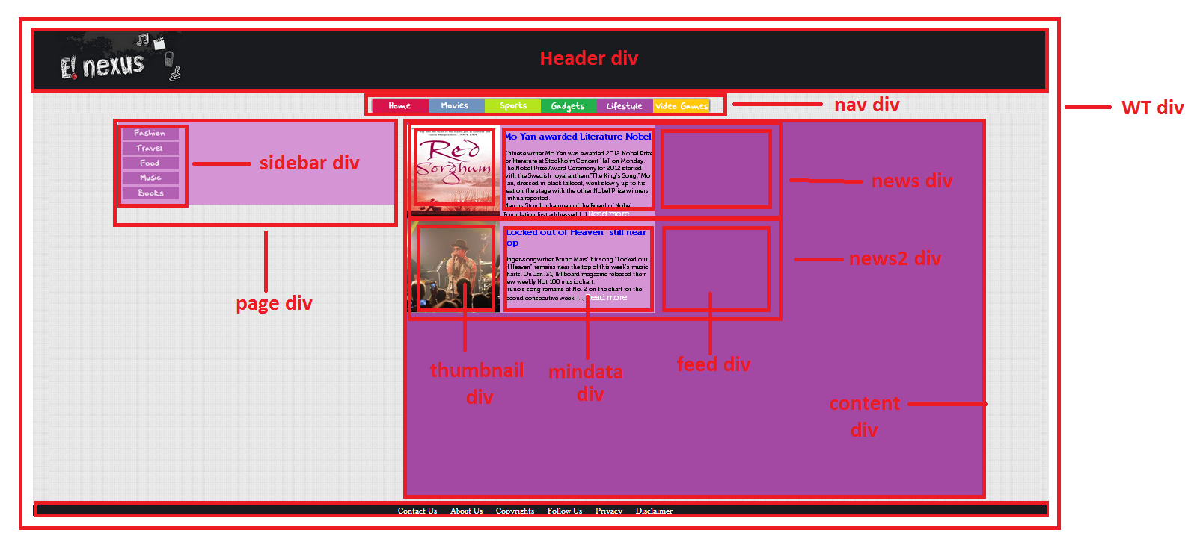

**Internal Content Page Structure**

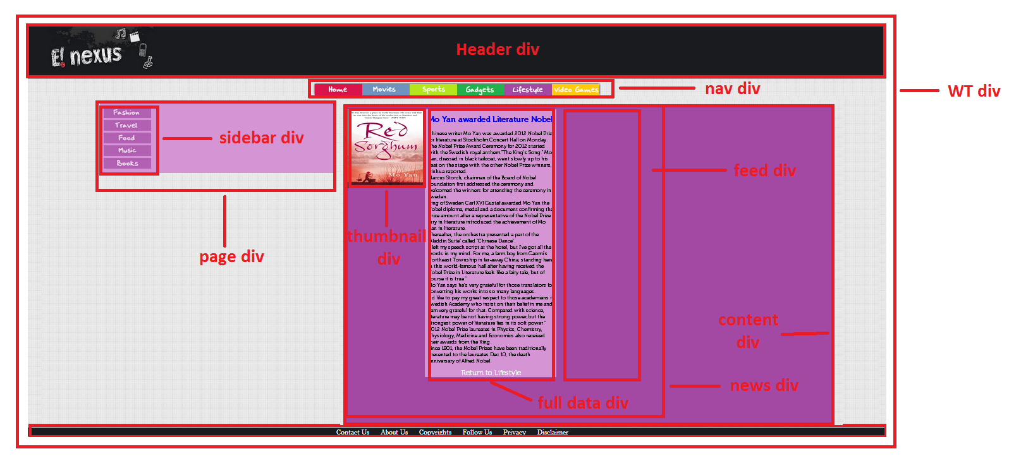

**Internal Page Divs Structure**

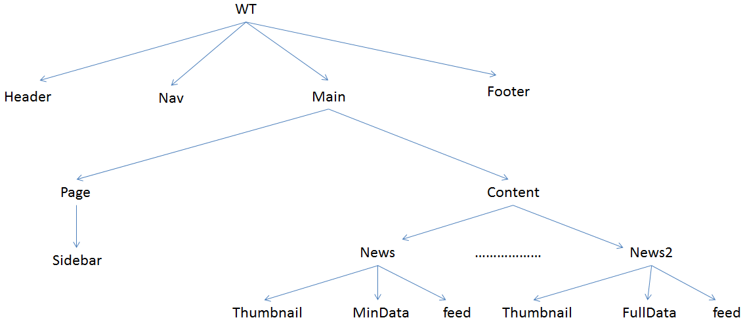

**CSS**

**Main Divs**

* **div id = wt**

#WT{

width:auto;

height:auto;

background-image:url('bg.jpg');

background-repeat:repeat-x repeat-y;

}

* **div id = header**

#header{

width:auto;

height:160px;

clear:both;

background-color:#1a1b1f;

border-bottom:outset;

border-bottom-width:10px;

}

* **div id = nav**

#nav{

width:auto;

height:auto;

clear:both;

padding-top:0;

margin-top:0;

}

* **div id = main**

#main{

width:100%;

height:auto;

float:left;

overflow:auto;

padding-bottom:27px

}

* **div id = footer**

#footer{

position:relative;

width:auto;

height:auto;

clear:both;

text-align:center;

background-color:#1a1b1f;

}

**Internal Divs**

* **div id = page**

#page{

width:28%;

height:auto;

position:relative;

float:left;

margin-top:30px;

margin-left:7%;

}

* **div id = sidebar**

#sidebar{

width:27%;

position:fixed;

background-color:#F60;

}

* **div id = content**

#content{

width:57%;

height:auto;

float:left;

margin-left:5px;

margin-top:30px;

}

* **div id = news**

#news{

margin-top:5px;

margin-bottom: 5px;

margin-left: 5px;

width:100%;

height:250px

}

* **div id = thumbnail**

#thumbnail{

float:left;

background-color:#D594D4

}

* **div id = mindata**

#mindata{

float:left;

width:400px;

height:250px;

padding-left:10px;

padding-right:5px;

background-color:#D594D4;

font-family:"Museo 300"

}

* **div id = live feed**

#live feed{

float:left;

width:100px;

height:auto;

}

* **div id = news2**

#news2{

margin-top:5px;

margin-bottom: 5px;

margin-left: 5px;

width:100%;

height:250px}

* **div id = fulldata**

#fulldata{

float:left;

width:400px;

height:auto;

padding-left:10px;

padding-right:5px;

background-color:#D594D4;

font-family:"Museo 300";

margin-bottom:5px;}